##Write down the query for creating the table “Studentx” of the following structure where  
**“deptno”** is a foreign key of table “**DEPT**”.

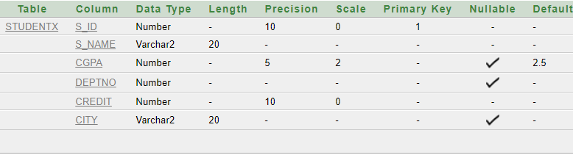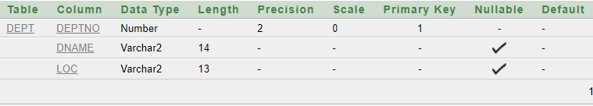

##After **“Studentx”** table creation is done insert the data given below into the created table.

